


Data Compliance Test (DCT)
Test Cases for
Radiology Image

<HCP Name>
Table of Contents
1. Testing Instructions to HCPs 3
1.1. Self-Service Testing Phase 3
1.2. Final Testing Phase 3
1.3. Preparation DCT Test Report 3
1.4. Test Cases Summary 4
2. Test Case Details 5
RID-001 [Mandatory] 5
RID-002 [Mandatory] 7
RID-003 [Required if perform referral case] 9
RID-004 [Required if support IOCM] 11
RID-005 [Mandatory in Final Test] 14
3. Appendix – Sample Messages 18
4. Appendix – Sample Results in eHR Viewer (EVE) 19

Testing Instructions to HCPs

Self-Service Testing Phase
- After development of the data upload programmes, you can use the Self-Service test accounts and test HCRs provided by Electronic Health System (eHealth) for connection to the eHealth testing environment and proceed with the self-service testing.
- You can proceed with the Self-service test at your own pace by following this Self-Service Testing Guide and using the test cases provided in section 2.
- You can verify the correctness and completeness of the data upload by:
  - checking the interface files / messages generated in your system against the sample expected results of interface files /messages for all test cases as provided;
  - checking the results on eHR Viewer (EVE) by logging into the testing eHealth with the provided test account; and
  - checking the upload status through Process Summary and Exception Report in eHR Inbox by logging into the testing eHealth.
- For data fields requiring eHR Codex values, you can refer the Code Sets provided with the Self-Service Kit.
- For details of technical requirements of the data interface files, please refer to the Developer Quick Guide for Radiology Image Upload.docx
- You are required to perform the test cases that are relevant to the radiology service supported by your clinic.
- When all required test cases can be completed smoothly and correctly in this phase, you can proceed to the Final Testing Phase and submit production environment setup form to eHR-IT for preparation.

Final Testing Phase
- You can start the Final Testing Phase once all test cases in the Self-Service Testing phase are passed.
- You should start Final Test by executing the test cases provided in section 2 with Final Testing HCRs provided by eHR-IT.
- You can verify the correctness and completeness of testing results by checking results in eHR Viewer (EVE) and the upload status through Process Summary and Exception Report in eHR Inbox.
- The Final Test will be considered PASSED if all the following criteria are met:
  - No exception records are reported from the uploads.
  - No manual interventions have been made to the data files / transactions.
- If the Final Test failed, you can re-attempt the Self-Service Test and Final Test until a successful run can be completed.

Preparation DCT Test Report
- Once you have successfully passed the Final Test based on the above criteria, you should complete this document by attaching the below items to this document at the appropriate space provided:
  - Actual data files uploaded
  - Screen-shot of each test case
- You are required to submit this completed ‘DCT Test Cases’ document to eHR-IT for further processing. eHR-IT will provide feedback within 10 working days.

Test Cases Summary
Scenario | Mandatory / Optional | Test Case ID | Step | HCR | Accession No.
New Image | M | RID-001 | 1a | HCR11 | ACC_01  ACC_02
New Image | M | RID-001 | 1b | HCR12 | ACC_03
Modified Exam & Image  Delete Exam | M | RID-002 | 2a | HCR11 | ACC_04
Modified Exam & Image  Delete Exam | M | RID-002 | 2b | HCR12 | ACC_03
Modified Exam & Image  Delete Exam | M | RID-002 | 2c | HCR11 | ACC_01  (exam only)
Referral Image | O  M [if HCP will perform HA/DH referral] | RID-003 | 3a | HCR13 | ACC_05
Referral Image | O  M [if HCP will perform HA/DH referral] | RID-003 | 3b | HCR13 | ACC_06
Delete Image by IOCM | O  M [if HCP will send IOCM to delete image in ERRSS] | RID-004 | 4a | HCR14 | ACC_07
Delete Image by IOCM | O  M [if HCP will send IOCM to delete image in ERRSS] | RID-004 | 4b | HCR14 | ACC_08
Delete Image by IOCM | O  M [if HCP will send IOCM to delete image in ERRSS] | RID-004 | 4c | HCR14 | ACC_09
Check anonymized production Image | M  [if in Final Testing] | RID-005 | 5 | HCR11 | ACC_21  to  ACC_44

Test Case Details
1 | Test Case ID | RID-001 [Mandatory]
 | Function Description | HCP performs HCR’s first radiology images upload corresponding to the radiology examination record/reports that uploaded to eHealth by DM Mode.
 | Subsequent case of | N/A
 | Testing Assumption | - <HCR11>-<HCR12> have already given sharing consents to the HCP.  - The EMR system will upload radiology examination transactions of HCR created by DM mode  - The radiology PACS system will upload images to eHealth image gateway after (~30 mins gap) the corresponding examination records are uploaded to eHealth.
 | Test Actions | HCP prepares below radiology examination records and images in EMR and PACS system:
 | Test Actions | 1a | HCR registers with documents pair. HCP uploads multiple historical images from PACS system to eHealth for her.
 | Test Actions | 1a | - Create 2 new radiology examination records in EMRS for <HCR11> with accession no.  Radiology image accession number. = <ACC_01> (source system provided)  &  Radiology image accession number. = <ACC_02> (source system provided)  - Create 2 new study images in PACS for <HCR11> with same accession no.  (0010,0010) Patient’s Name = <English Surname>^<English GivenName>  (0010,0020) Patient ID = <Document Number>  (0010,0021) Issuer of Patient ID = <Document Type>  (0010,0030) Patient’s Birth Date = <DOB(YYYYMMDD)>  (0010,0040) Patient’s Sex = <Sex>  (0008,0050) Accession Number = <ACC_01>  (0008,0060) Modality = <Possible radiology services provided by HCP>  &  (0010,0010) Patient’s Name = <English Surname>^<English GivenName>  (0010,0020) Patient ID = <Document Number>  (0010,0021) Issuer of Patient ID = <Document Type>  (0010,0030) Patient’s Birth Date = <DOB(YYYYMMDD)>  (0010,0040) Patient’s Sex = <Sex>  (0008,0050) Accession Number = <ACC_02>  (0008,0060) Modality = <Possible radiology services provided by HCP>
 | Test Actions | 1b | HCR registers with HKID. HCP uploads 1 historical radiology images for her.
 | Test Actions | 1b | - Create new radiology examination record in EMRS for <HCR12> with accession no.  Radiology image accession number = <ACC_03> (source system provided)  - Create new study images in PACS for <HCR12> with same accession no.  (0010,0010) Patient’s Name = <English Surname>^<English GivenName>  (0010,0020) Patient ID = <HKIC Number>  (0010,0021) Issuer of Patient ID = ID  (0010,0030) Patient’s Birth Date = <DOB(YYYYMMDD)>  (0010,0040) Patient’s Sex = <Sex>  (0008,0050) Accession Number = <ACC_03>  (0008,0060) Modality = <Possible radiology services provided by HCP>  (0020,000E) Series Instance UID = <SeriesUID> (Source system provided)
 | Expected Behavior | - HCP’s EMR system uploads data file (‘Zip file’ and ‘Zip Control File’) for the created radiology examination records.  - After radiology examinations are sent, HCP’s PACS system uploads images to eHealth.  - HCP verifies the image upload status by reviewing the 'Image Upload Process Summary Report' and 'Image Upload Exception Report' in eHR Inbox.  - HCP verifies the completeness and correctness of image uploaded in eHR Radiology Image Viewer
 | Results Verification | - HCP verifies if the uploaded radiology images can be properly presented in eHR Radiology Image Viewer from EVE.  - On the following day, from ‘Image Upload Process Summary Report’, HCP reviews [study status], [image count] received in eHealth are matched with PACS system for those studies successfully processed.  - On the following day, from ‘Image Upload Exception Report’, HCP reviews errors for those studies unsuccessfully processed.
 | Actual Result  (Screenshot / Attachment) | Image Files Uploaded:
 | Actual Result  (Screenshot / Attachment) | Attachment/Screenshot:  <Attached the screen shots of records uploaded in eHR Viewers>  <Attached the screen shots of images displayed in eHR Radiology Image Viewers>  <Attached the screen shots of Image Upload Process Summary & Exception Report >
 | Remark
 | Testing Date
 | Verified By

2 | Test Case ID | RID-002 [Mandatory]
 | Function Description | HCP uploads whole set of study images for any subsequent changes after first uploaded to eHealth by INC Mode
 | Subsequent case of | RID-001
 | Testing Assumption | - HCP has already verified upload from RID-001 have been processed successfully with correct result.  - The EMR system will upload radiology examination transactions of HCR created by INC mode  - The radiology PACS system will upload images to eHealth image gateway after (~30 mins gap) the corresponding examination records are uploaded to eHealth.
 | Test Actions | HCP prepares below updates for below radiology examination records and images in EMR and PACS system:
 | Test Actions | 2a | HCR has performed new radiology exam at HCP and HCP uploads for her under the sharing consent.
 | Test Actions | 2a | - Input new radiology examination record in EMRS for <HCR11> with new accession no.  Radiology image accession number = <ACC_04> (Source system provided)  - Create new study in PACS for <HCR11> with same accession no.  (0010,0010) Patient’s Name = <English Surname>^<English GivenName>  (0010,0020) Patient ID = <Document Number>  (0010,0021) Issuer of Patient ID = <Document Type>  (0010,0030) Patient’s Birth Date = <YYYYMMDD>  (0010,0040) Patient’s Sex = <Sex>  (0008,0050) Accession Number = <ACC_04>  (0008,0060) Modality = <Possible radiology services provided by HCP>
 | Test Actions | 2b | HCP wants to rectify radiology exam record and images which have been uploaded to eHealth previously.
 | Test Actions | 2b | - Modify examination description for record of (1b) for <HCR12>  Radiology image accession number = <ACC_03>  - Modify study by adding 1 series to (1b) that was uploaded for <HCR12>  (0010,0010) Patient’s Name = <English Surname>^<English GivenName>  (0010,0020) Patient ID = <HKIC Number>  (0010,0021) Issuer of Patient ID = ID  (0010,0030) Patient’s Birth Date = <YYYYMMDD>  (0010,0040) Patient’s Sex = <sex>  (0008,0050) Accession Number = <ACC_03>  (0020,000E) Series Instance UID = <Add another new SeriesUID>
 | Test Actions | 2c | HCP wants to remove the images which have been uploaded to eHealth previously by deleting examination record
 | Test Actions | 2c | - Trigger delete examination record of (1a) for <HCR11>  Transaction type = “D”  Radiology image accession number = <ACC_01> (Source system provided)  (Refer Developers’ Quick Guide for Radiology Examination Records Upload for delete examination record that contain accession number.)
 | Expected Behavior | - HCP’s EMR system uploads data file (‘Zip file’ and ‘Zip Control File’) for the new and updated examination records.  - After examination records are sent, HCP’s PACS system uploads images to eHealth.  - HCP verifies the image upload status by reviewing the 'Image Upload Process Summary Report' and 'Image Upload Exception Report' in eHR Inbox.  - HCP verifies the completeness and correctness of image uploaded in eHR Radiology Image Viewer
 | Results Verification | - HCP verifies if the newly added radiology study, series and images can be properly presented in eHR Radiology Image Viewer from EVE.  - HCP verifies if the deleted examination record and images cannot be viewed in EVE.  - On the following day, from ‘Image Upload Process Summary Report’, HCP reviews [Status], [Series count] and [Image Count] received in eHealth are matched with PACS system for those studies successfully processed.  - On the following day, from ‘Image Upload Exception Report’, HCP reviews errors for those studies unsuccessfully processed.
 | Actual Result  (Screenshot / Attachment) | Data Files Uploaded:
 | Actual Result  (Screenshot / Attachment) | Attachment/Screenshot:  <Attached the screen shots of records uploaded in eHR Viewers>  <Attached the screen shots of images displayed in eHR Radiology Image Viewers>  <Attached the screen shots of Image Upload Process Summary & Exception Report>
 | Remark
 | Testing Date
 | Verified By

3 | Test Case ID | RID-003 [Required if perform referral case]
 | Function Description | HCP performs image upload to eHealth for radiology examination referred by HA or DH
 | Subsequent case of | NIL
 | Testing Assumption | - <HCR13> have already given sharing consents to the HCP.  - The EMR system will include Referring Number and HCR’s Identity from Referral letter with the radiology examination that uploads to eHealth.  - The radiology PACS system will upload images to eHealth image gateway after (~30 mins gap) the corresponding examination records are uploaded to eHealth.
 | Test Actions | HCP prepares below radiology examination records and images in EMR and PACS system:
 | Test Actions | 3a | HCP wants to send images of a referral case to HA or DH through eHealth platform.
 | Test Actions | 3a | - Input new referral radiology examination record in EMRS for <HCR13> with new accession no.  Radiology image accession number = <ACC_05> (Source system provided)  Radiology referring number = <3098159131: 24111100000001>  (Refer Developers’ Quick Guide for Radiology Examination Records Upload for requirement of “Radiology referring number”)  - Create new study in PACS for <HCR13> with same accession no.  (0010,0010) Patient’s Name = <English Surname>^<English GivenName>  (0010,0020) Patient ID = <HKIC Number>  (0010,0021) Issuer of Patient ID = ID  (0010,0030) Patient’s Birth Date = <YYYYMMDD>  (0010,0040) Patient’s Sex = <Sex>  (0008,0050) Accession Number = <ACC_05>  (0008,0060) Modality = <Possible radiology services provided by HCP>
 | Test Actions | 3b | HCP wants to rectify the radiology upload from non-referral to referral cases.
 | Test Actions | 3b | - Input new radiology examination record in EMRS for <HCR13> with new accession no.  Radiology image accession number = <ACC_06> (Source system provided)  Radiology referring number = <Empty>  - Create new study in PACS for <HCR13> with same accession no.  (0008,0050) Accession Number = <ACC_06>  (0008,0060) Modality = <Possible radiology services provided by HCP>  - On the following day, modify examination from non-referral to referral  Radiology image accession number = <ACC_06> (Source system provided)  Radiology referring number = <3098159131: 24111100000002>  - Then, reupload previous images study  (0008,0050) Accession Number = <ACC_06>
 | Expected Behavior | - HCP’s EMR system uploads data file (‘Zip file’ and ‘Zip Control File’) for the created radiology examination records.  - After radiology examinations are sent, HCP’s PACS system uploads images to eHealth.  - HCP verifies the image upload status by reviewing the 'Image Upload Process Summary Report' and 'Image Upload Exception Report' in eHR Inbox.  - HCP verifies the completeness and correctness of image uploaded in eHR Radiology Image Viewer.
 | Results Verification | - HCP verifies if the uploaded radiology images can be properly presented in eHR Radiology Image Viewer from EVE.  - On the follow day, from ‘Image Upload Process Summary Report’, HCP reviews [Referral Case] indicator = DH or HA, [Status], [Series Count] and [Image Count] received in eHealth are correct for those studies successfully processed.  - On the following day, from ‘Image Upload Exception Report’, HCP reviews errors for those studies unsuccessfully processed.
 | Actual Result  (Screenshot / Attachment) | Data Files Uploaded:
 | Actual Result  (Screenshot / Attachment) | Attachment/Screenshot:  <Attached the screen shots of records uploaded in eHR Viewers>  <Attached the screen shots of images displayed in eHR Radiology Image Viewers>  <Attached the screen shots of Image Upload Process Summary & Exception Report>
 | Remark
 | Testing Date
 | Verified By

4 | Test Case ID | RID-004 [Required if support IOCM]
 | Function Description | HCP initiates image deletion in eHealth.
 | Subsequent case of | NIL
 | Testing Assumption | - HCP has already performed RID-001 successfully with correct result.  - The HCP imaging system will construct an IHE Image Object Change Management (IOCM) rejection note message and send to eHealth.  - The radiology PACS system will upload images to eHealth image gateway after (~30 mins gap) the corresponding examination records are uploaded to eHealth.
 | Test Actions | 4a | HCP delete images in local PACS system due to quality reason
 | Test Actions | 4a | - Create new radiology examination records in EMRS for <HCR14> with accession no.  Radiology image accession number = <ACC_07> (source system provided)  - Create new study images in PACS for <HCR14> with same accession no.  (0008,0050) Accession Number = <ACC_07>  (0008,0060) Modality = <Possible radiology services provided by HCP>  - Delete image in local PACS system of <HCR14>:  (0008,0050) Accession Number = <ACC_07>  (0008,0016) SOP Class UID = “1.2.840.10008.5.1.4.1.1.88.59”  (0008,0060) Modality = “KO”  (0040,A043) Concept Name Code Sequence  (0008,0100) Code Value = 113001  (0008,0104) Code Meaning = Rejected for Quality Reasons
 | Test Actions | 4b | HCP delete images, then rectify image and re-upload in same day
 | Test Actions | 4b | - Create new radiology examination records in EMRS for <HCR14> with accession no.  Radiology image accession number = <ACC_08> (source system provided)  - Create new study images in PACS for <HCR14> with same accession no.  (0008,0050) Accession Number = <ACC_08>  (0008,0060) Modality = <Possible radiology services provided by HCP>  (0020,000E) Series Instance UID = <SeriesUID>  - Delete image in local PACS system of <HCR14>:  (0008,0050) Accession Number = <ACC_08>  (0008,0016) SOP Class UID = “1.2.840.10008.5.1.4.1.1.88.59”  (0008,0060) Modality = “KO”  (0040,A043) Concept Name Code Sequence  (0008,0100) Code Value = 113001  (0008,0104) Code Meaning = Rejected for Quality Reasons  - IN THE SAME DAY of step 4b-1, modify the study by adding 1 series to <ACC_08>, immediate reupload the whole rectified study after image is deleted in eHealth.  (0008,0050) Accession Number = <ACC_08>  (0020,000E) Series Instance UID = <SeriesUID>  (0020,000E) Series Instance UID = <SeriesUID_new>
 |  | 4c | HCP delete images, then rectify image and re-upload in the following day
 |  | 4c | - Create new radiology examination records in EMRS for <HCR14> with accession no.  Radiology image accession number = <ACC_09> (source system provided)  - Create new study images in PACS for <HCR14> with same accession no.  (0008,0050) Accession Number = <ACC_09>  (0008,0060) Modality = <Possible radiology services provided by HCP>  (0020,000E) Series Instance UID = <SeriesUID>  - Delete image in local PACS system of <HCR14>:  (0008,0050) Accession Number = <ACC_09>  (0008,0016) SOP Class UID = “1.2.840.10008.5.1.4.1.1.88.59”  (0008,0060) Modality = “KO”  (0040,A043) Concept Name Code Sequence  (0008,0100) Code Value = 113001  (0008,0104) Code Meaning = Rejected for Quality Reasons  - THE FOLLOWING DAY of step 1, modify the study by adding 1 series to <ACC_09>, immediate reupload the whole rectified study after image is deleted in eHealth.  (0008,0050) Accession Number = <ACC_09>  (0020,000E) Series Instance UID = <SeriesUID>  (0020,000E) Series Instance UID = <SeriesUID_new>
 | Expected Behavior | - HCP’s imaging system constructs IOCM message and sends to eHealth.  - HCP verifies the image in eHR EVE.  - HCP verifies the image status by reviewing the 'Image Upload Process Summary "Report' and 'Image Upload Exception Report' in eHR Inbox.
 | Results Verification | - Verify in EVE  (4a) HCP verifies if the uploaded radiology images are removed while only the examination record can be viewed in EVE.  (4b) HCP verifies if the uploaded radiology images are removed while only the examination record can be viewed in EVE.  (4c) HCP verifies if the uploaded radiology images can be properly presented in eHR Radiology Image Viewer from EVE.  - From ‘Image Upload Process Summary Report’, HCP reviews  (4a) study [Status] received in eHealth is Deleted  (4b) study [Status] received in eHealth is Deleted  (4c) study [Status] received in eHealth is Active with 1 series added  - From ‘Image Upload Exception Report’, HCP reviews errors for those studies unsuccessfully processed.
 | Actual Result  (Screenshot / Attachment) | Data Files Uploaded:
 | Actual Result  (Screenshot / Attachment) | Attachment/Screenshot:  <Attached the screen shots of records uploaded in eHR Viewers>  <Attached the screen shots of images displayed in eHR Radiology Image Viewers>  <Attached the screen shots of Image Upload Process Summary & Exception Report>
 | Remark
 | Testing Date
 | Verified By

5 | Test Case ID | RID-005 [Mandatory in Final Test]
 | Function Description | HCP uploads anonymized production image and check in eHR Radiology Image Viewers for each uploading modality type
 | Subsequent case of | N/A
 | Testing Assumption | - <HCR11> have already given sharing consents to the HCP.  - The EMR system will upload radiology examination transactions corresponding to each testing modality.  - The radiology PACS system will upload images to eHealth image gateway after (~30 mins gap) the corresponding examination records are uploaded to eHealth.
 | Test Actions | For each modality type, HCP prepares two radiology examination records and two anonymized image studies from production data for each modality device.
 | Test Actions | 5 | - Create new radiology examination records in EMRS for <HCR11> with different accession numbers.  - Create new study images in PACS for <HCR11> corresponding to each examination record.  Mark “NA” if HCP will not upload the modality to eHealth
  # | Modality | Accession Number  (Source system provided)
  1 | Angio | <ACC_21>
  2 | Angio | <ACC_22>
  3 | BI | <ACC_23>
  4 | BI | <ACC_24>
  5 | CT | <ACC_25>
  6 | CT | <ACC_26>
  7 | Fluor | <ACC_27>
  8 | Fluor | <ACC_28>
  9 | IR | <ACC_29>
  10 | IR | <ACC_30>
  11 | MRI | <ACC_31>
  12 | MRI | <ACC_32>
  13 | NM | <ACC_33>
  14 | NM | <ACC_34>
  15 | PET/CT | <ACC_35>
  16 | PET/CT | <ACC_36>
  17 | PET/MR | <ACC_37>
  18 | PET/MR | <ACC_38>
  19 | US | <ACC_39>
  20 | US | <ACC_40>
  21 | XRay | <ACC_41>
  22 | XRay | <ACC_42>
  23 | Other | <ACC_43>
  24 | Other | <ACC_44>
 | Expected Behavior | - HCP’s EMR system uploads data file (‘Zip file’ and ‘Zip Control File’) for the created radiology examination records.  - After radiology examinations are sent, HCP’s PACS system uploads images to eHealth.  - HCP verifies the image upload status by reviewing the 'Image Upload Process Summary Report' and 'Image Upload Exception Report' in eHR Inbox.  - HCP verifies the completeness and correctness of image uploaded in eHR Radiology Image Viewer.
 | Results Verification | - HCP verifies if the uploaded radiology images can be properly presented in eHR Radiology Image Viewer from EVE.  - On the following day, from ‘Image Upload Process Summary Report’, HCP reviews [study status], [image count] received in eHealth are matched with PACS system for those studies successfully processed.  - On the following day, from ‘Image Upload Exception Report’, HCP reviews errors for those studies unsuccessfully processed.
 | Actual Result  (Screenshot / Attachment) | Image Files Uploaded:
 | Actual Result  (Screenshot / Attachment) | Attachment/Screenshot:  <Attached the screen shots of records uploaded in eHR Viewers>  <Attached the screen shots of images displayed in eHR Radiology Image Viewers>  <Attached the screen shots of Image Upload Process Summary & Exception Report >
 | Remark
 | Testing Date
 | Verified By

Appendix – Sample Messages
Test Case ID | Step No. | File Type | DICOM FILE /Bulk Load Format
RID-001 | 1a | DICOM
RID-001 | 1b | DICOM
RID-002 | 2a | DICOM
RID-002 | 2b | DICOM
RID-002 | 2c | Data File (DF)  (delete examination)
RID-003 | 3a | DICOM
RID-003 | 3a | Data File (DF)  (examination record of referral case)
RID-004 | 4a | DICOM

Appendix – Testing HCP and HCRs Information
Sample Message
Self-Service Testing | To be provided by eHR-IT later
Final Testing | To be provided by eHR-IT later

  - eHR-IT will provide other sets of testing HCRs for HCP to perform Self-Service testing and Final testing respectively.

Appendix – Sample Results in eHR Viewer (EVE)
- After logging on the eHealth portal and searching the HCR, click Tree node of Radiology Record in Home Page.
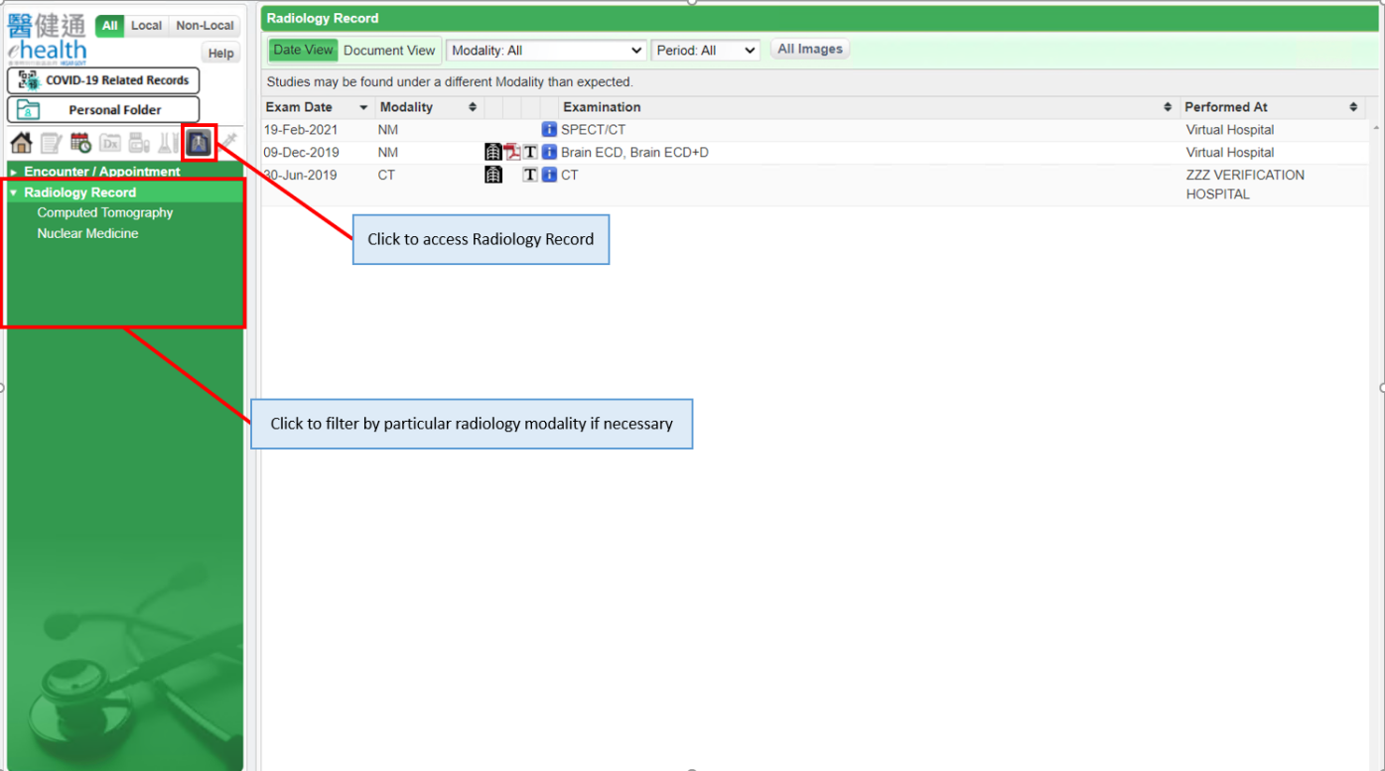

- To show the radiology report, you can click the radiology record. The report will be shown at the lower part of the page.
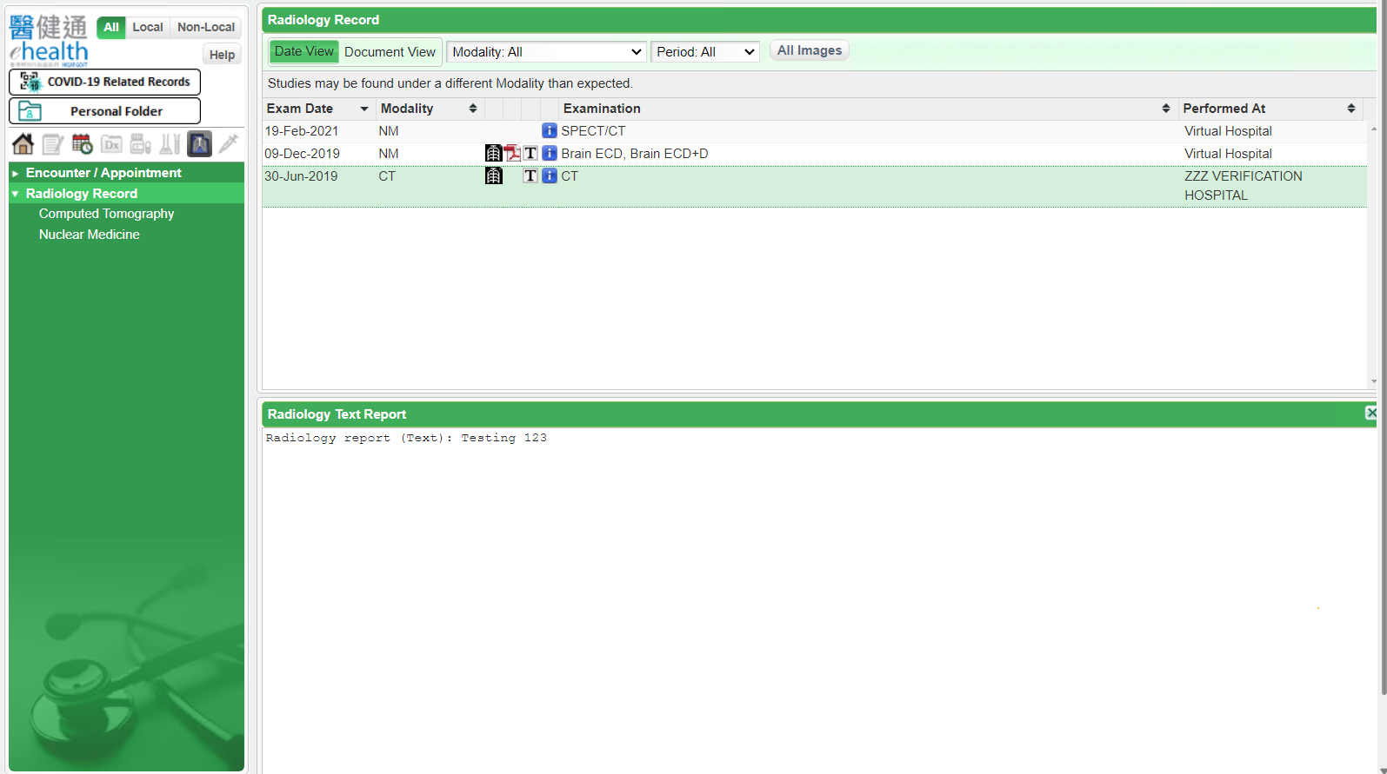

- Click Image icon to show images from Image Viewer.
